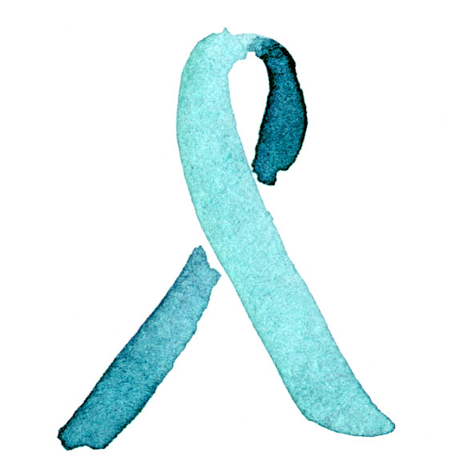
I support domestic violence awareness!

#purple4peace #NotInMyCity

