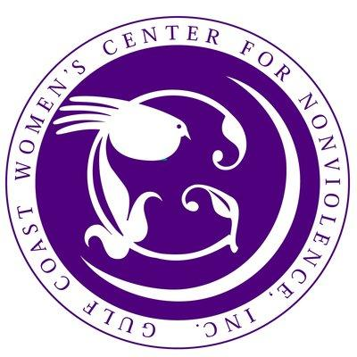
#DVAM
Domestic Violence Awareness Month 2015
31 Days of Making a Difference

Each day in October you can help raise awareness about domestic violence. Just use one of the suggested messages for your Facebook status update or send as a tweet on Twitter.

October 1, 2015
October is Domestic Violence Awareness Month! Get involved, you can make a difference! #DVAM #VAW #GCWCFN

October 8, 2015
43% of #college women experience violence and abusive dating behaviors. #DVAM #VAW #GCWCFN

October 9, 2015
1 in 3 teens reports knowing someone who has been punched, kicked, or hurt by their dating partner. http://bit.ly/jmbJbk #DVAM #VAW #GCWCFN
October 2, 2015
4,774,000 U.S. women experience physical violence by an intimate partner annually. #DVAM #VAW #GCWCFN

October 3, 2015
#DV affects millions of people across the nation regardless of age, economic status, race, education, or sexual orientation. #DVAM #VAW #GCWCFN

October 10, 2015
One in four women will experience domestic violence in her lifetime. You can prevent it. http://youtu.be/-RaA7CoJNZI #DVAM #VAW #GCWCFN

October 4, 2015
81% of women stalked by abusive partner have also been physically abused by them. #DVAM #VAW #GCWCFN

October 11, 2015
Almost 1/3 of female #murder victims reported in police reports are killed by an intimate partner. #DVAM #VAW #GCWCFN

October 5, 2015
The cost for #domesticviolence exceeds $5.8 billion annually. We provide free counseling for victims. Call 228.435.1968. #DVAM #VAW #GCWCFN

October 12, 2015
#Domesticviolence is the leading cause of injurys to women 15-44. More than car accidents/muggings/rapes combined. #DVAM #VAW #GCWCFN

October 6, 2015
Please share the Nat’l Domestic Violence Hotline. Advocates are available 24/7. You are not alone. 800.799.SAFE #DVAM #VAW #GCWCFN @NCADV

October 13, 2015
$21 a day can provide a victim w/meals, clothing, shelter, counseling and more. Donate today! http://tinyurl.com/8ockld3 #DVAM #VAW #GCWCFN

October 7, 2015
Don’t forget tomorrow is #Purple4Peace Thursday. Wear your purple proudly; take a picture & let us know! #DVAM #VAW #GCWCFN

October 23, 2015
Advocacy can help a victim find her voice. Get involved, become an #advocate today! #DVAM #VAW #GCWCFN

October 14, 2015
Don’t forget tomorrow is #Purple4Peace Thursday. Wear your purple proudly; take a picture & let us know! #DVAM #VAW #GCWCFN

October 24, 2015
Females ages 20-24 are at the greatest risk for becoming a victim of domestic violence. #DVAM #VAW #GCWCFN
October 15, 2015
Women w/developmental #disabilities are 10x more likely to experience sexual violence than women w/o disabilities. #DVAM #VAW #GCWCFN

October 25, 2015
#Financial Abuse is one of the least known but 1 of the most powerful tactics trapping a victim in the relationship. #DVAM #VAW #GCWCFN
October 16, 2015
Everyone can speak out against #domesticviolence. The problem won’t stop unless we stand together & say “no more!” #DVAM #VAW #GCWCFN

October 26, 2015
8,000,000. The number of days of paid work women lose annually due to domestic violence. #DVAM #VAW #GCWCFN
October 17, 2015
1 in 7 men will experience severe violence by an intimate partner in their lifetime. #DVAM #GCWCFN

October 27, 2015
#Emotional abuse occurs in all abusive relationships. It is a tactic that causes extreme damage to the victim’s self esteem. #DVAM #VAW #GCWCFN
October 18, 2015
Domestic violence is preventable. We can stop #DV and promote #healthy relationships, families and communities. #DVAM #VAW #GCWCFN

October 28, 2015
#Emotional abuse is so damaging many survivors say they would rather “be hit” than endure the emotional abuse. http://bit.ly/pZuW4w #DVAM
October 19, 2015
Girls who are victims of dating violence are 4 to 6 times more likely than non-abused girls to become pregnant. #DVAM #VAW #GCWCFN

October 29, 2015 On average, 3 women die at the hands of a current or former intimate partner every day. Help us end Domestic Violence. #DVAM #VAW #GCWCFN
October 20, 2015 Healthy relationships require #love #respect #equality and #communication. What makes your relationship healthy? #DVAM #VAW #GCWCFN

October 30, 2015
To the #advocates & #volunteers who answer hotline calls, work in shelters, assist in safety plans #ThankYou #DVAM #VAW #GCWCFN

October 21, 2015
Don’t forget tomorrow is #Purple4Peace Thursday. Wear your purple proudly; take a picture & let us know! #DVAM #VAW #GCWCFN

October 31, 2015
We must continue to raise awareness year round. Please raise your voice and join the movement to end violence. #DVAM #VAW #GCWCFN

October 22, 2015
Pay attention to the “red flags “& trust your instincts. If you feel your relationship may be abusive reach out for #support. #DVAM #GCWCFN

